Wrist Bones Anatomy
Osteology Wrist Anatomy consists of 8 carpal bones that’s arranged in two rows, the proximal row which contains from lateral to medial (scaphoid, lunate, triquetrum, and pisiform), while the distal row contains the following from lateral to medial (trapezium, trapezoid, capitate, and hamate).

Scaphoid:
The scaphoid is the largest of the proximal carpal bones, and its shape resembles that of a boat or canoe (thus the old term navicular). The scaphoid bone links the proximal and distal carpal rows and helps provide stability to the wrist joint.
The scaphoid is tethered to the proximal carpal row by a number of strong ligamentous attachments, and two-thirds of its surface area is articular.
- The proximal surface of the scaphoid is convex and articulates with the radius.
- The medial surface is concave and articulates with the capitate. The articulating surface for the lunate is flat.
- The distal surface consists of two convex facets for articulation with the trapezium and trapezoid (the scapho-trapezio-trapezoid joint).
The round tubercle on the inferolateral part of its anterior (palmar) surface serves as the attachment of the flexor retinaculum and the abductor pollicis brevis (APB).
The blood vessels to this bone enter the scaphoid at or distal to the wrist. This configuration predisposes a fracture on the proximal aspect to aseptic necrosis.
In addition, as the scaphoid plays a critical role in coordinating and stabilizing movements between the proximal and the distal rows of the carpals, damage to the intrinsic and extrinsic ligaments that support the scaphoid can result in persistent pain and dysfunction with loading activities.
See Also: Scaphoid Shift Test

Lunate:
The lunate articulates between the scaphoid and the triquetrum in the proximal carpal bone row. Its smooth convex proximal surface articulates with the radius and the TFCC at the lunate fossa. Its lateral surface contains a flat semilunar facet for the scaphoid. The medial surface articulates with the triquetrum. The distal surface is deeply concave and articulates with the edge of the hamate in adduction and
the medial aspect of the capitate.

Triquetrum:
The triquetrum is a pyramid-shaped bone. It articulates with the pisiform on its distal anterior (palmar) surface at the pisiform–triquetral joint. The almost square distal–medial surface of the triquetrum articulates with the concavo–convex surface of the hamate. The ulnar collateral ligament (UCL) attaches to the medial and posterior (dorsal) surfaces of the triquetrum. The proximal surface of the triquetrum articulates with the TFCC in full adduction. The lateral surface of the triquetrum articulates with the lunate

Pisiform:
The pisiform, as its name implies, is shaped like a “P” with a posterior (dorsal) flat articular facet for the triquetrum. The pisiform, formed within the tendon of the flexor carpi ulnaris (FCU), is a sesamoid bone and serves as an attachment for the flexor retinaculum, abductor digiti minimi (ADM), UCL, pisohamate ligament, and pisometacarpal ligament. The pisiform also functions to increase the flexion moment of the FCU. As mentioned, the pisiform articulates with the anterior (palmar) surface of the triquetral and is thus separated from the other carpal bones, all of which articulate with their neighbors. The pisiform is closely related to the ulnar artery and nerve on its radial border, the nerve being the closer.

Trapezium:
The trapezium has a groove on its medial anterior (palmar) surface which contains the tendon of
the flexor carpi radialis (FCR). To its margins are attached two layers of the flexor retinaculum. The opponens pollicis (OP) is between the flexor pollicis brevis (FPB) distally and the APB proximally. The lateral surface serves as an attachment site for the radial collateral ligament and capsular ligament of
the Thumb CMC joint. The distal articulating surface of the trapezium is saddle shaped. Medially, its concave surface articulates with the trapezoid, whereas more distally its convex surface articulates with the second metacarpal base. Proximally, its concave surface articulates with the scaphoid.

Trapezoid:
The trapezoid is small and irregular. The distal surface articulates with the grooved second metacarpal base. The medial surface articulates via a concave facet with the distal part of the capitate. The lateral surface of the trapezoid articulates with the trapezium, and its proximal surface articulates with the scaphoid bone.

Capitate:
The capitate is the most central and the largest of the carpal bones. Its distal aspect articulates with the third metacarpal base. Its lateral border articulates with the medial side of the second metacarpal base. The convex proximal head of the capitate articulates with the lunate and scaphoid. The medial surface of the head articulates with the lunate, and the lateral aspect of the head articulates with the scaphoid. Medially, the capitate articulates with the hamate. With its central location, the capitate serves as the keystone of the proximal transverse arch. This arch is important to the prehensile activity of the hand.

Hamate:
The hamate is a cuneiform bone and contributes to the medial wall of the carpal tunnel. To the hook (hamulus) of the hamate is attached the flexor retinaculum. The hamate articulates with three carpal bones and two metacarpals. The medial surface articulates with the triquetrum and by association with the pisohamate ligament, the pisiform. The lateral surface articulates with the capitate. On its distal aspect the hamate articulates with the fourth and fifth metacarpal heads. 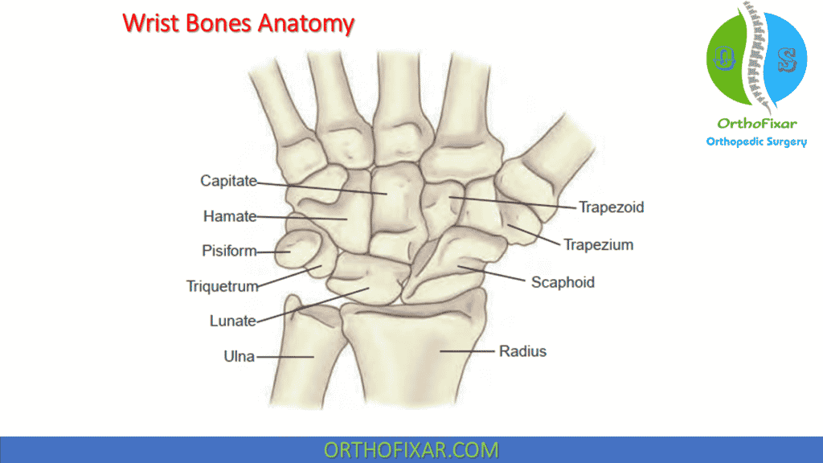

Distal Radioulnar Joint
The distal radioulnar articulation, formed by the ulnar head and the ulnar notch of the radius, allows 1 degree of freedom of movement: pronation and supination. The distal and proximal radioulnar joints work together to produce those motions. Restriction of motion at either of these joints limits pronation and supination of the entire forearm. At the distal radioulnar joint, pronation and supination are produced by the radius’ gliding around the ulna.

Radiocarpal joint
Ellipsoid shape involving distal radius and the scaphoid, lunate, and triquetrum. It’s located at the level of the crease of proximal wrist flexion.
Extrinsic ligaments bridge carpal bones to radius or metacarpals (radioscaphocapitate); while intrinsic attach carpal bones together (scapholunate).